assign weighted signal:

Signal | Effect on Interest
Prospect asked implementation question | +8
Prospect invited another stakeholder | +10
Prospect asked pricing question | +7
Prospect said "need internal approval" | +5
Prospect challenged ROI | -4
Prospect no-showed follow-up meeting | -12
No email reply for 14 days | -10
Asked for security docs | +12
Competitor mentioned | -5
Asked for contract | +20

Then the engine computes a weighted score from 0-100.
Example:
- Started at 42%
- Pricing question: +7
- Added procurement stakeholder: +10
- Requested ROI deck: +6
- Mentioned competitor concern: -5
- Delayed next meeting by 2 weeks: -8
Final score = 52%
Add a new service: Agent 5 – Interest & Momentum Engine
Inputs:
- Meeting transcript
- Summary Agent output
- Objection Agent output
- Speaking Skill Agent output
- CRM metadata
- Email engagement
- Meeting frequency
- Stakeholder count
- Proposal status
- Previous meeting history
Outputs:
- interest_score
- momentum_score
- stage_confidence
- next_best_actions
- risk_flags
- predicted_next_stage
- predicted_days_to_close

Suggested Scoring Dimensions
Instead of a single raw score, use multiple sub-scores:
Dimension | Weight
Engagement | 20%
Buying Intent | 25%
Stakeholder Involvement | 15%
Urgency / Timeline | 15%
Objection Severity | 15%
Relationship Trust | 10%
Interest Score = weighted average of all dimensions
Example:
- Engagement: 80
- Buying Intent: 65
- Stakeholder Involvement: 50
- Urgency: 40
- Objection Severity: 55
- Trust: 75
Final Interest = 61%
That is much more stable and explainable than a single LLM-generated number.

Dynamic Task Generation: Tasks should not be mapped directly from stage.
Instead: Stage + missing evidence + risk flags = tasks

Example:  Current state:  - Interest = 58%  - Trust exists  - Buying committee missing  - ROI unclear  - Procurement not involved  Then AI generates:  - Schedule technical validation meeting with IT stakeholder  - Send ROI calculator deck  - Introduce implementation timeline  - Share customer case study from same industry  - Ask about procurement process and legal review timing | example:  Interest = 74%  Negotiation stage  But objections detected:  - Security concern  - Budget concern  - CFO approval missing  Generated tasks:  - Share security compliance document  - Create phased pricing proposal  - Schedule executive sponsor call  - Send CFO-facing ROI summary  - Confirm approval process and target decision date  So tasks become contextual and evidence-driven, not static.
The timeline should also be dynamic.
Example logic:
- If interest is increasing rapidly and multiple stakeholders are engaged → shorten timeline
- If objections remain unresolved and no meetings scheduled → extend timeline
- If legal/procurement involved → add delay buffer
- If champion identified and next meeting booked → increase close probability
Condition | Timeline Adjustment
Next meeting booked within 3 days | -5 days
Procurement involved | +10 days
No reply for 2 weeks | +14 days
Champion identified | -7 days
Security review pending | +5 days
Then UI can show:
- Predicted next stage in 5 days
- Predicted negotiation completion in 14 days
- Predicted close date in 28 days
- Confidence: 72%

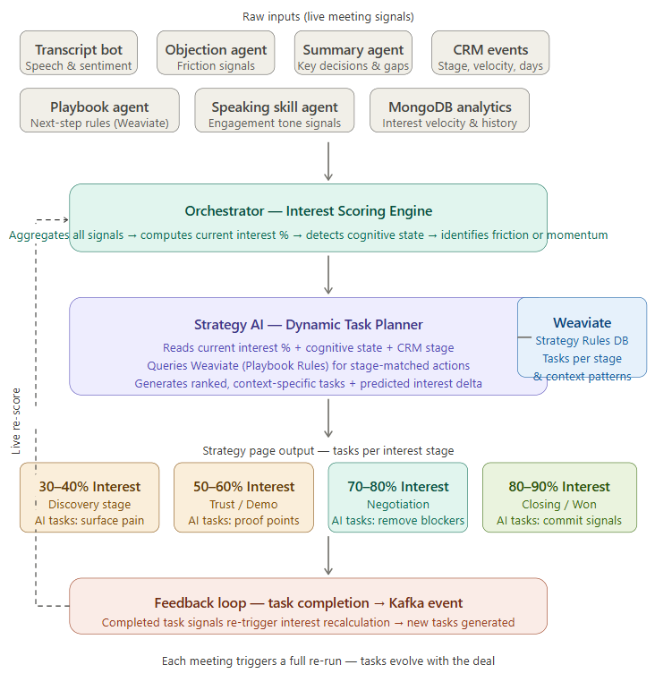
live signal → score → plan → task → feedback
The AI reads the current context, reasons about why interest is where it is, and generates tasks that are specific to this deal, this meeting, this friction point.

How the engine works, step by step:
1. Signal aggregation (your existing agents do this) After every meeting, the Orchestrator collects signals from all your agents: what objections appeared (Objection Agent), what decisions were made (Summary Agent), tone and engagement quality (Speaking Skill Agent), historical interest velocity from MongoDB, and CRM stage/timing data.
2. Interest scoring & cognitive state detection The Orchestrator already computes the interest %. The key addition is why the interest is at that level — is it plateauing? Dropping? Did it spike after a specific topic? This becomes the context_reason that gets passed to the Strategy AI.
3. Strategy AI — the new planner This is the agent you're adding. It receives:
- Current interest % and cognitive state (e.g. "Trust, 58%")
- The context_reason from the scoring engine ("3 budget objections in last meeting, no champion identified")
- Queries Weaviate (a new Strategy Rules collection) with semantic search: "what tasks apply to Trust stage with budget friction and no champion?"
Weaviate returns ranked playbook actions for that pattern. The AI re-ranks them by predicted interest delta — which task is most likely to move the needle — and generates 2–4 specific, personalized tasks with deadlines.
4. Stage-specific task cards Instead of a static timeline, the Strategy page renders task cards per stage, each card containing AI-generated tasks with their predicted impact. These are not template sentences — they reference actual meeting content ("you mentioned price concerns → schedule a ROI workshop before the proposal").
5. Feedback loop via Kafka When a seller marks a task complete, this fires a Kafka event back into the Orchestrator. The interest model re-scores, the Strategy AI re-plans, and new tasks appear. The timeline literally evolves as the deal progresses.

